Show your Semper pride with a car magnet!
Only $3 each….
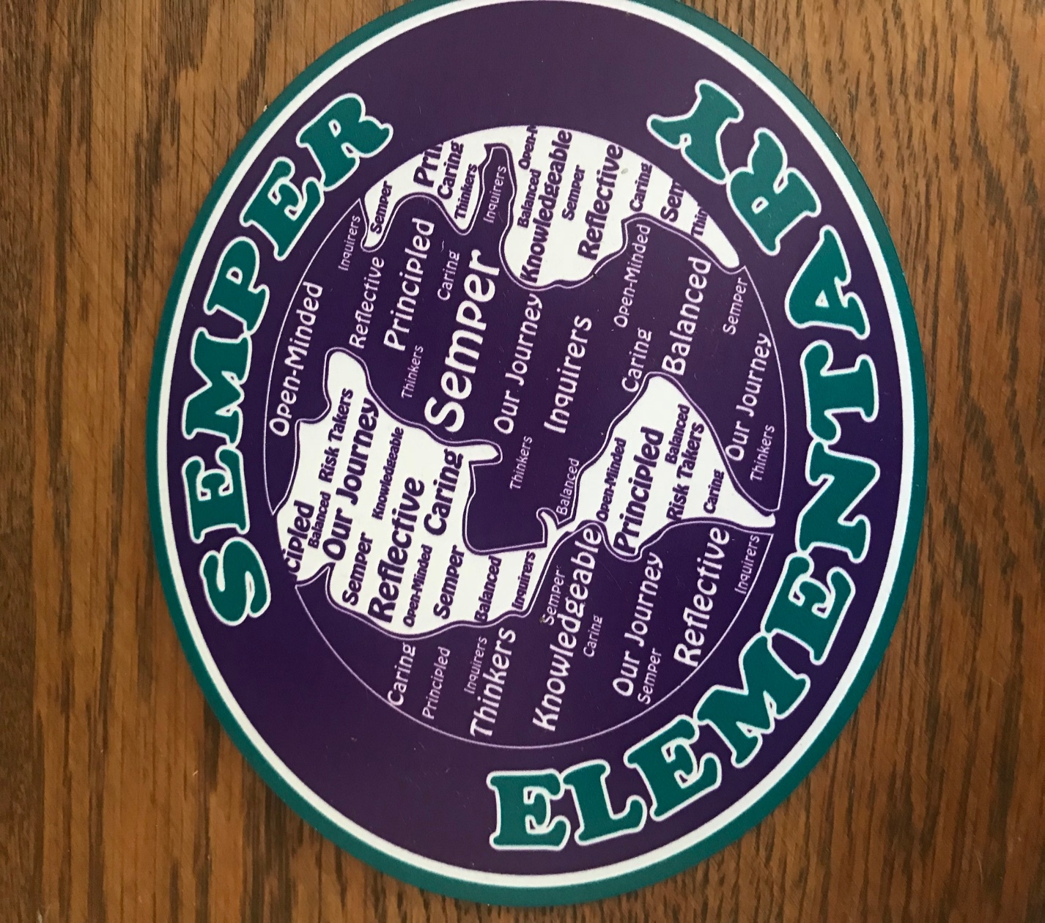
(logo designed by our very own Mrs. Gutierrez, 2nd grade teacher!)

I would like _______ magnets for a total of $ _________
Student Name: ____________ Teacher’s Name: ________________
Turn in to your child’s teacher along with cash or check made out to Semper PTA

